

SIMATS ENGINEERING

Saveetha Institute of Medical and Technical Sciences Chennai- 602105
Student Name: T.Praneetha Reg. No.:192412588
Course Code: CSA0208 Slot:D
Course Name: C Programming
Course Faculty: Dr Jaya Sudha

Project Title:
OFFLINE PLAGIARISM DETECTION AND DOCUMENT SIMILARITY ANALYSIS SYSTEM
Module Photographs:
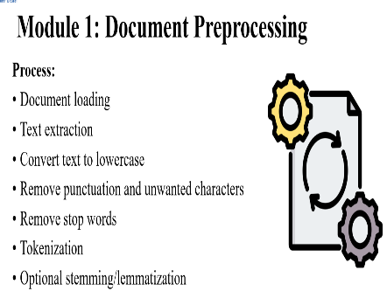
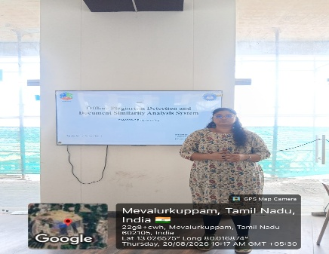
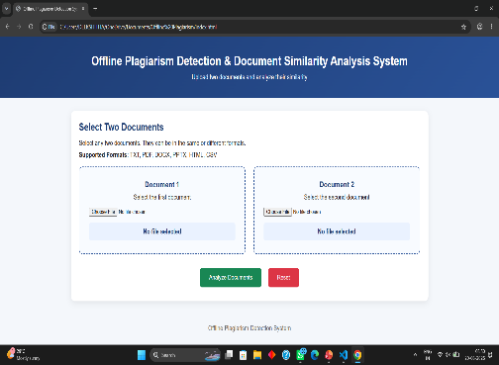

Project Description:
Document Preprocessing is responsible for preparing the input documents for plagiarism detection and document similarity analysis. In this module, I worked on loading the submitted documents, extracting their text, converting the content into lowercase, and removing punctuation and unwanted characters. Stop words were removed to reduce unnecessary words, followed by tokenization to divide the text into individual words. Optional stemming or lemmatization was applied to normalize related word forms. This preprocessing produces clean and standardized text, which is then used by the subsequent similarity-analysis modules for accurate comparison.

Student Signature Guide Signature

